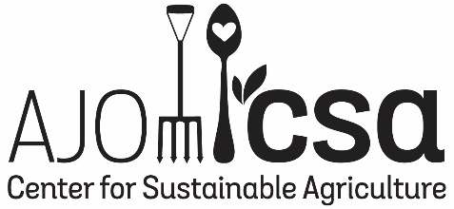

2019/20 “ADOPT–A–SONORAN–DESERT–CROP” PROGRAM

Name: ________________________________________________________________________

Contact (email/phone) __________________________________________________________

Member of Ajo Gardeners Network? _______________________________________________

Garden location: ________________________________________________________________

Brief garden description (including soil preparation, watering method and schedule, if any):

______________________________________________________________________________

How can we help you in this process? _______________________________________________

______________________________________________________________________________

Plant(s) selected: _______________________________________________________________

I hereby pledge to participate in the 2019/2020 “Adopt-a-Sonoran-Desert-Crop Program” in order to help preserve the unique heirloom food plant varieties of the Sonoran Desert. I will grow the plant(s) using my best knowledge, will keep basic growing records (including planting, germination, flowering and seeding dates), will provide a short report to program coordinators, and if the plant produces seeds, return half of the seed collected back to the program. I also agree to share my process and photos of the process for the purposes of education, and if possible, participate in 2020 Ajo Garden Tour or AZ Beginning Farmers Forum to share my story with other gardeners.

_____________________________________ __________________
(Signature) (Date)

Please return the completed form to Caitlin Smyth at Ajo Center for Sustainable Agriculture, phone: 520-405-4872, email: outreach@ajocsa. com. For free gardening workshops and announcements join our mailing list, or follow us on Facebook.

Administrator’s note:
* Seeds of _______________________________________ returned to the seed bank on ______________

